Case studies from some of the participants can be found below:
Paul MacDonald
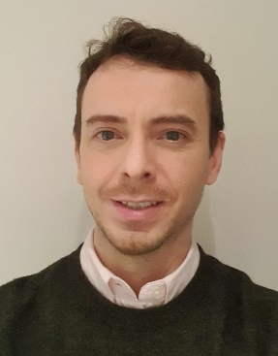
Age:42
Occupation: IT Operations Manager
Residency: Glasgow
Comment on the Citizens’ Panel: “I was surprised and encouraged by how many people on the panel have been and are keen to contribute to the work of government and parliament; the overarching recommendations that citizens should have more opportunity to make their views known is a first step in improving public participation for a fairer society and growing trust in the government.”
“The main issue I have found with contributing my experience and thoughts to parliamentary process' was having awareness of what issues are being discussed in parliament; there are many issues I care about and would like to feed into the wider discussion but the opportunity to contribute or legislation has passed by the time I'm aware of the discussion, which is frustrating and I realise many people feel the same way.”
John Angus Sultman
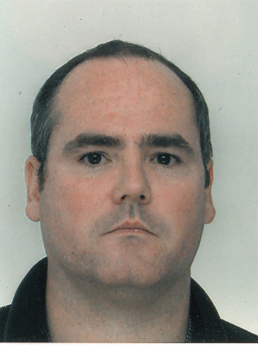
Age: 46
Occupation: Retired Royal Navy Submariner, currently working as a purchaser for a ship management company.
Residency: Shettleston, Glasgow

Comment: “The Citizens’ Panel was a great experience. I learnt so much about Parliament, Scotland and indeed myself. I had the chance to meet some interesting people, presenters and participants alike. It was interesting to interact with such a diverse group with different backgrounds, experiences and viewpoints but all having the common wish to make things a little better.”
“Some of our recommendations are just building on work that is already being done but a few of them would be a bigger change and hopefully make a real difference.”

Maria Schwarz
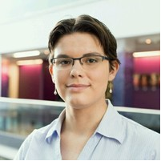
Age 28:
Occupation: Scientist
Residency: Edinburgh

Comment on the Citizens’ Panel: “The Citizens' Panel was a great opportunity to have the needs of people like me, such as my friends and colleagues, heard.”
Ronnie Paterson
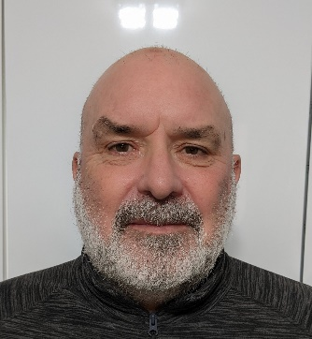
Age: 59
Occupation: Retired Police Officer
Residency: Kincardine, Fife

Comment on the Citizens’ Panel: “It has been a wonderful experience being part of the panel.”
Gillian Ruane
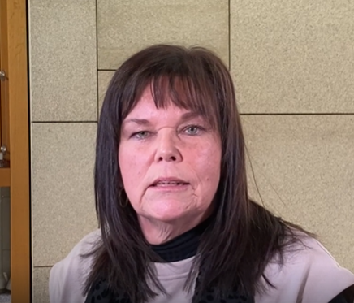
Age: 60
Occupation: Residential Childcare worker
Residency: Dumfries

Comment on Citizens’ Panel: “My experience is very positive. I thoroughly enjoyed it. It was a very good mix of people from across Scotland. The team at Parliament were very supportive and passionate about letting us have our voices heard. There was no hidden agenda other than the question that was set. For people who might have dismissed it and put their invitation in the bin, I would say think again as it was a great experience”
ENDS

