CHURCH SUNDAY SERVICES

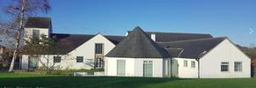
DRYLAW PARISH CHURCH
Groathill Road North
EH4 2RG
Scottish Charity No. SC005744

Sunday services have resumed in the church - 10.30am every Sunday morning
In order to arrange the seating please phone by Thursday lunchtime to
07703 178731

Our Sunday services are at 11am
Booking one of the few available places by leaving a message on 0131-467-2922
with your name, number of people attending and phone number.
.

