- Context

Edinburgh Community Solar Co-operative (ECSC) is a Community Benefit Society with over 540 members and currently generates electricity from Solar PV installations on 24 Edinburgh City Council host buildings. The installations were funded via a public share offer with priority given to Edinburgh residents. Surplus funds generated after payment of share interest is allocated to a community benefit fund which is used to offer grants to host buildings for the purpose of:
- Improving host building sustainability
- Supporting initiatives which have the most significant carbon savings impact
- Alleviating fuel poverty
- Encouraging behavioural change relating to sustainability

With this project, ECSC are focusing on two areas of deprivation in Edinburgh, namely, Edinburgh North and Leith, and Craigmillar. Edinburgh North and Leith (pop. 93,605) is an urban constituency which contains the highest proportion of residents living in tenements and flats of any parliamentary constituency in the United Kingdom. The constituency also contains some of the highest levels of fuel poverty in Edinburgh, with deprived areas such as Granton, Pilton and South Leith identified within the top 10%. Similarly, Craigmillar, located approximately 3 miles south east of the city centre is among the most deprived 20% of areas in Scotland.

Renewable energy technologies can help to alleviate fuel poverty, stimulate community regeneration create jobs, empower communities and bring generate income for communities. Adoption of Solar PV in particular has traditionally been highest amongst those with higher disposable incomes, however, falling prices has meant that Solar PV is becoming more affordable for those on lower incomes and could help to alleviate fuel poverty by lowering consumer’s energy bills.

1.2. Project Aims

In the areas of Edinburgh North & Leith and Craigmillar, ECSC’s key aims are to:
- Promote the benefits of renewable energy (with an emphasis on solar)
- Increase individual and community awareness of UK energy system changes
- Encourage more community organisations and individuals to install solar PV installations and reduce their carbon footprint
- Gauge interest and commitment from community organisations to participate in the establishment of renewable energy hubs in Edinburgh North & Leith, and Craigmillar, as a means of pooling knowledge and support in the form of a grassroots community resource
- Encourage more people in the target areas to invest in future ECSC share offers and reap the associated financial benefits
- Materials

Two information leaflets were produced as part of the pre-engagement phase. The first leaflet (Appendix A) was designed to:
- Promote the activities of ECSC across Edinburgh and encourage applications to their community benefit fund from those buildings with ECSC solar PV installations.
- Increase awareness of, and encourage Edinburgh resident to invest in, their upcoming 2nd share offer (April 2020).
- Demonstrate to other community groups the benefits of Solar PV and stimulate interest in a potential 3rd group installation funded via share offer.

The second leaflet (Appendix B) was designed as a practical step-by-step guide aimed at community organisations, which details the practical aspects of developing a solar PV project from initial feasibility to buying in technical advice and potential funding options. It brings together a range of information from a variety of sources.
Both leaflets have been used extensively in all community engagement events and will continue to be used as a marketing/awareness tool by ECSC moving forward.

- Engagement Overview

A community engagement process was carried out between October 2019 and January 2020 with the aim of establishing a baseline of knowledge around Solar PV technology and increasing awareness of its benefits. This was achieved by targeting individual community members and community groups using ECSC as a demonstration of what is possible using the following methods:

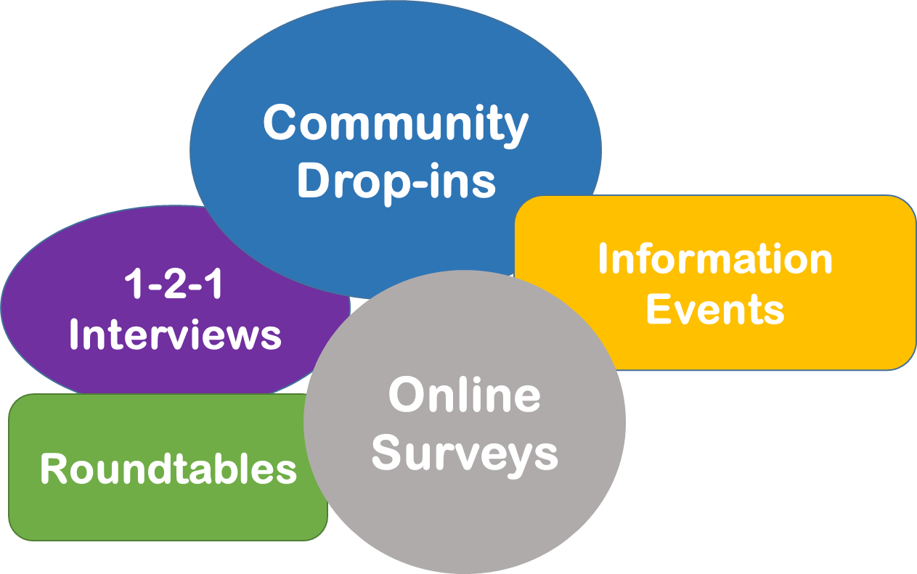

ECSC employed a local community engagement specialist to map the key contacts within the target areas, and design and distribute the online surveys as part of the first phase of outreach. Contacts and data gathered through the online surveys were intended to form the basis for more focused outreach as part of phase 2 which included community drop-ins, 1-2-1 interviews, roundtables and community information events.

Early in the process it became clear that the level of engagement from groups and individuals in Craigmillar was particularly low, particularly compared with Edinburgh North and Leith. The reasons for this are not clear and given the late start of the project and the short timescale for completion, it was decided that, for phase 2, our time would best be spent focusing our efforts in Edinburgh North and Leith.

Community Views

The following key issues were identified from the engagement process:

- More information was needed locally about renewable energy, carbon reduction measures and their benefits
- Local, community benefit grants were not well publicised and there was a general lack of awareness of ECSC’s community share offer, the share offer process and its associated benefits.
- The establishment of a community-led renewable energy hub was met with a positive response and several local community groups expressed an interest in being involved

Key Challenges

- North Edinburgh & Leith and Craigmillar are areas which suffer from high fuel poverty and many do not have the disposable income to invest in share offers or install renewable energy systems
- While there was generally good awareness of issues such as the roll-out of SMART meters, the growth of EVs and more green tariffs being offered by energy suppliers, there was little understanding of the broader changing energy system and its impact on community energy
- A general lack of knowledge and capacity within community organisations was putting them off pursuing renewable energy projects

4. Proposed Actions

The following actions are hoped to be delivered via the establishment of a community renewable energy hub comprising a consortium of local community organisations. It was agreed that a hub need not be a physical entity but could involve bringing together members of community groups across North Edinburgh & Leith which would form a knowledge base which groups or individuals could access for practical advice. Potential key partners include the following:

- Edinburgh Community Solar Co-operative
- Edinburgh Leisure
- Community Energy Scotland
- Leith Crops in Pots
- Muirhouse Housing Association
- North Edinburgh Childcare
- North Edinburgh Arts
- Granton Walled Garden
- Granton Hub

The hub will bring groups together in order to:
- support each other and facilitate future community renewable energy developments
- develop local knowledge and confidence around renewable energy
- provide an avenue for sharing experiences and learnings via online communications and face-to-face meetings
- enable funding applications to be applied for as a group/consortium or to encourage individual organisations to pursue their own projects
- have a positive impact on meeting carbon reduction targets, community cohesion and resilience, and help to reduce energy bills

Actions | Description | Timescale
Raise awareness of renewable energy technologies and their benefits | Offer advice and support to coummunity groups and individuals using ECSC Solar PV installations as demonstrators to indicate what is possible. Invite expert speakers/consultants to provide advice on science/technology, infrastructure and funding considerations | Short-term
Raise awareness of carbon reduction measures and their benefits | Offer advice, support and signposting services to community groups and individuals on existing energy efficiency measures, green energy tariffs and other carbon reduction activities | Short-term
Raise awareness of energy system changes and their impacts | Offer advice, support and signposting services to community groups and individuals on issues such as the growth of renewable energy, electric vehicles and battery storage | Short-term
Raise awareness of ECSC and their work as well as other local renewable energy initiatives | Promote ECSC upcoming community share offer and existing community benefit fund to existing ECSC members | Short-term
Carry out a local energy audit | Establish what has already been done with renewables to inform future priorities | Short – medium term
Establish relationships with key partners to identify and implement potential renewable energy projects | Develop and maintain a relationship with the local council to identify opportunities for renewable energy generation and demand reduction in Edinburgh | Short-term
Increase local capacity to set up and run the hub | Employ a ‘green guru’ to co-ordinate the hub and its activities | Short-term
Install Solar PVs on community buildings across the target areas | Carry out feasibility study to assess scope for developing a group installation of solar PV on community buildings funded via share offer | Medium term
Investigate battery storage integration within existing ECSC community solar PV buildings to maximise self-use and improve energy savings | Carry out feasibility study to look at options for integrating battery storage into existing solar PV installations | Medium term

5. Next Steps

ECSC is committed to helping Edinburgh become a net zero carbon city by 2030 but reduced funding and grant support for communities has meant that it is becoming increasingly difficult to raise awareness about the importance of reducing our carbon footprint, particularly in areas of high fuel poverty. ECSC, in partnership with several key partners, believe that establishing a community energy hub in North Edinburgh and Leith, using buildings hosting ECSC solar panels as demonstrator sites, will increase neighbourhood awareness of renewable energy and encourage people to go ‘green’.

The long-term vision is to develop the hub along the lines of a successful community initiative in Oxford called Low Carbon Hub who:

- Raise money through community share offers, giving local people the opportunity to invest in renewable energy projects
- Re-invest 100% of their own surplus to support further local carbon-cutting initiatives
- Act as a hub, helpdesk and mentor for local community groups.

5.1. Funding Options

A key aspect to developing a successful hub is one of capacity. Many community organisations are run by volunteers and do not have the staff resource to drive this initiative forward. We intend to apply for funds to employ a ‘green guru’ to develop the hub concept and work within the community to:

- Give advice on fuel poverty to households/kids in schools
- Work with organisations to do carbon neutral audits and help them create action plans
- Bring in experts to build confidence and share tips
- Approach private organisations for support and funding

A previous unsuccessful application was made to the Climate Challenge Fund therefore we have identified the following funding programmes for future applications:
- The National Lottery Community Fund (Scotland) - Community Led Activity
- CARES Enablement Grant

Changeworks (2015) “Fuel Poverty Mapping of the City of Edinburgh”

