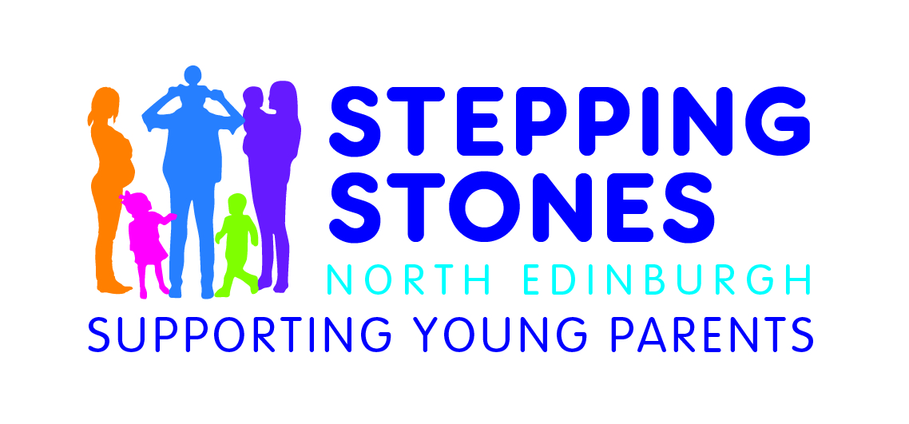

Stepping Stones North Edinburgh

Early Years Practitioner

Part-time (24 hours p/w) Please note this post works 42 weeks out of 52 with the fixed holidays predominately following the school holidays.

The salary below is pro-rated across the year.

Salary - £10,828 – Qualified at HNC/SVQ 3 level
Salary - £9,625 – Qualified at NC/SVQ 2 level

The Early Years Practitioner is responsible for providing safe and stimulating care and play provision for children aged 0-5 years within our early years setting.

Application pack can be found on our website; www.steppingstonesnorthedinburgh.co.uk under the recruitment section.
Closing date: 30th January 2019

