14 Lower Granton Walk and Cycle Improvements Feedback Form
The City of Edinburgh Council (CEC) is delivering a package of improvements to the QuietRoute network for walking and cycling across the city. During the Preliminary Design and Detailed design stages, CEC and AECOM are undertaking a range of consultation approaches with stakeholders and the public to achieve better design outcomes.
The proposals for Lower Granton include the widening of the existing path for walking and cycling along McKelvie Parade, the extension of the shared use path and a new crossing on Lower Granton road just before Granton Square. The aim of this project is to provide a safe and desirable path for pedestrians and cyclist from the Trinity Road junction to Oxcraig St and in the long term connect up to the Cramond Esplanade. There will be an official round of consultation later in the year that will include the detailed design drawings. We wanted to take this opportunity to update you on some key areas of change and get your feedback.
1. Benches at Eastern Breakwater
The Eastern Breakwater junction/Wardie Bay access has been identified as a key location in the area that could benefit from benches and cycle parking. We have suggested bench platforms on either side of the junction with access via a gentle ramp, this will provide excellent views out to the Firth of Forth.
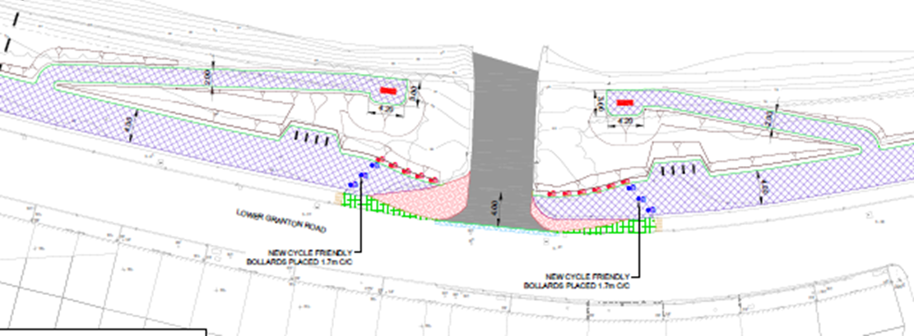

New cycle friendly bollard
New cycle friendly bollard

1.1 To what extent do you support the idea of benches at the Eastern Breakwater junction?
Strongly Support |  | Support
Neutral |  | Oppose
Strongly Oppose
Further Comment:

2. Excess Excavated Soil
There is going to be 1200cubic square meters of excavated soil from the building of the new path. We want this project to be as sustainably as possible and to come in on budget, in order to achieve this it is going to be highly beneficial to reuse the excavated soil on site.

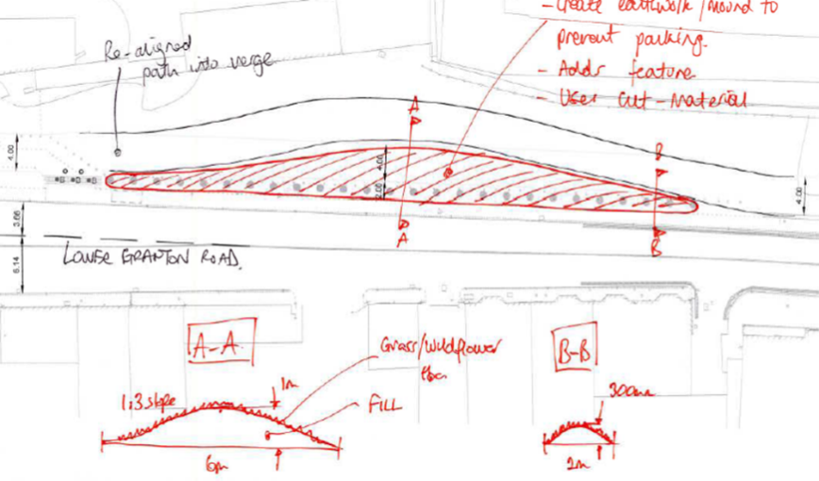
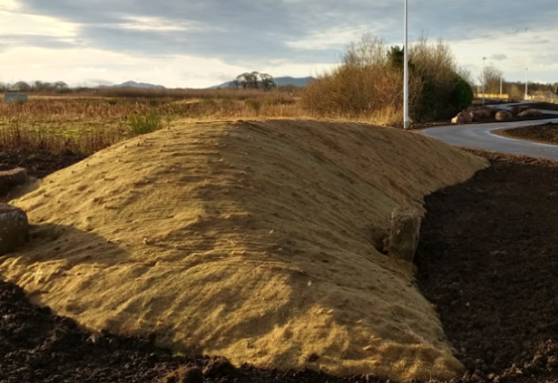

2.1 We would like to use 10% of the additional excavated material to create a bund at the western end of the project. This will be to replace the existing bollards. To what extent do you support this?
Strongly Support |  | Support
Neutral |  | Oppose
Strongly Oppose
Further Comment:

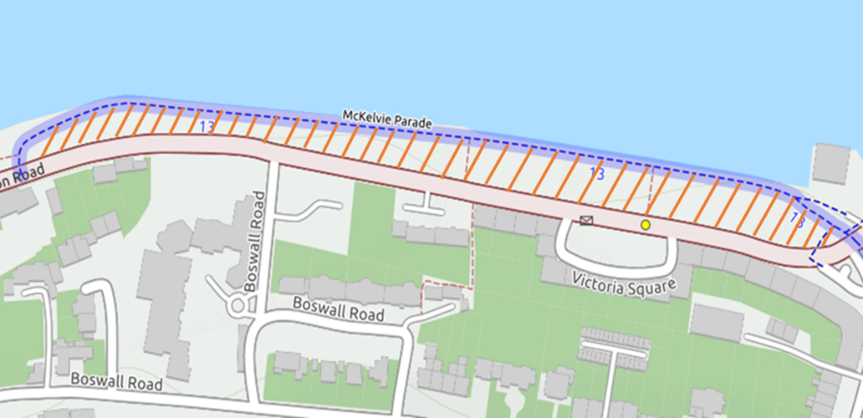
Potential area for distribution of excavated material

2.2 How would you like to see the remaining 90% of excavated material used?
Reused on site with some minimal landscaping options such as the inclusion of undulations in the green space (marked above).
Reused on site but keep the area flat and raise whole green space area (marked above) by 100mm.
I would prefer the excavated material not to be reused on site
Further Comments:

3. Tree Planting
The Trees and Woodland team are very keen to include some tree planting as part of the project. We are conscious that we do not want to obstruct anyone’s view. A Trees and Woodland officer looked at locations where there would be minimal impact to resident’s views. He has kindly put together a number of recommendations for tree locations, see below. This is every location he believes a tree could be located not every location we want to locate a tree.
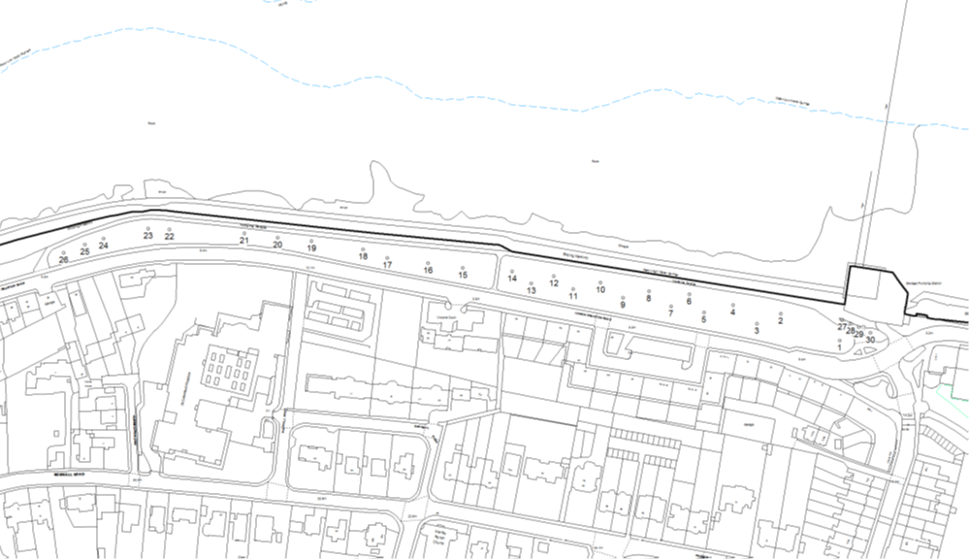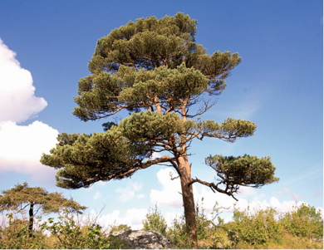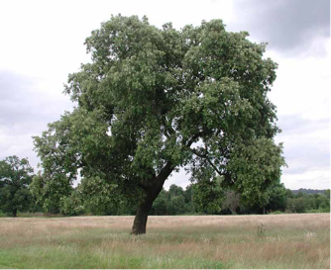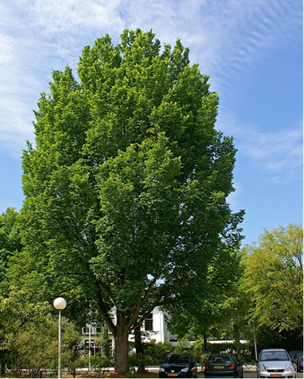

3.1 To what extent do you support tree planting as part of this proposal?
Support the planting of as many trees as possible
Support but would just like to see a few trees planted
Neutral
Oppose
Strongly Oppose
Further Comments:

3.2 Wild Flower planting
The option for wild flower planting is being explored as a way to increase biodiversity in the area. This would alter the mowing regime but would provide a well maintained management strip along the perimeter and path edges to ensure the green space looks like a managed site and has not just been left to go wild. In addition to this there is the opportunity to plant some bulbs and shrubs around the benches.
3.3 To what extent do you support wild flower and shrub planting in the area?
Strongly Support |  | Support
Neutral |  | Oppose
Strongly Oppose
Further Comment:
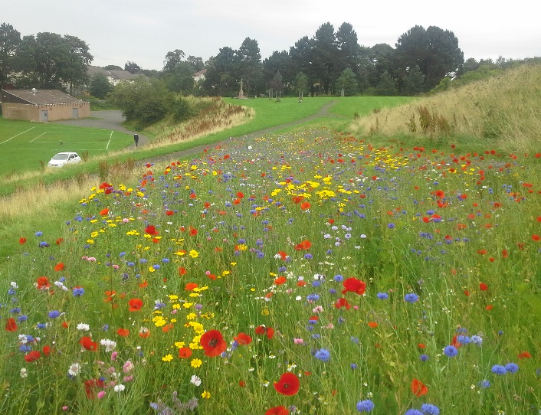
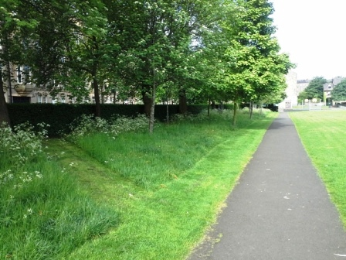
Montgomerry St Park
Red Hall Park Meadows

4. Path Realignment
Original drawings from the consultation in Jan 2017 saw the new path from the Wardie Garage up to Granton Harbour Square running fairly close to the sea wall. After further analysis this was deemed to be too costly due to the extra amount of excavation and earth works required. We have as such relocated the new path to run parallel to the existing pavement to create as much greenspace to the north side of the path as possible.
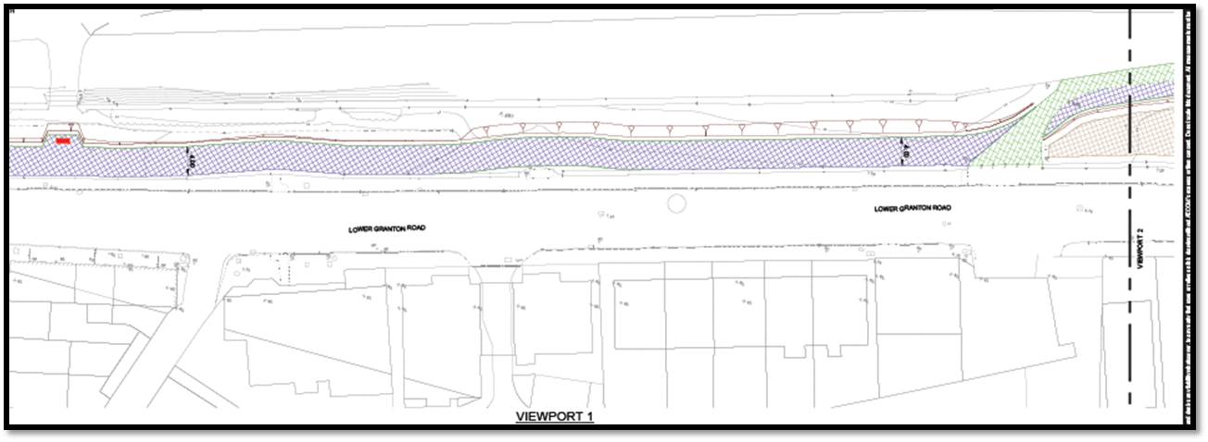

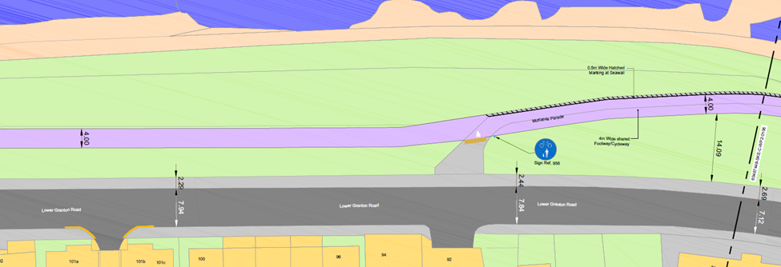
New Alignment
Alignment from consultation 01/17

4.1 To what extent do you support the new path alignment?
Strongly Support |  | Support
Neutral |  | Oppose
Strongly Oppose
Further Comment:

