Peoples Health Trust Community Conversations Project – End of Year News Letter
Hello everyone,
As 2017 comes to an end we were keen to highlight the work we have been doing and look at the next steps for the new year ahead. We would also like to thank you for your contribution and involvement in the Community Conversations project and invite you to our Christmas Party on the 21st of December at Muirhouse Millennium Centre. Come along for some festive fun, it starts at 3:00 and finishes around 5:00.
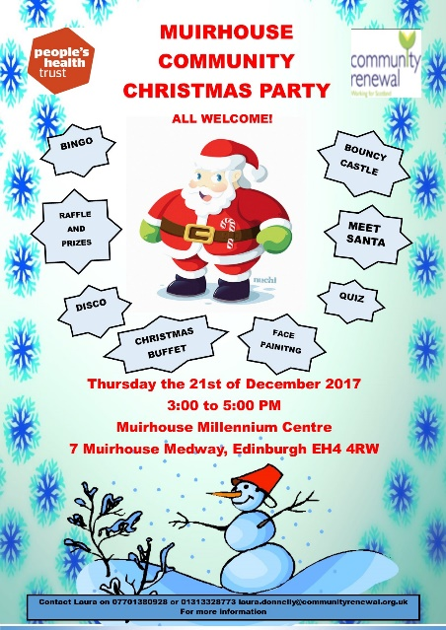
Our next Community Forum will be held on Tuesday the 9th of January, from 5:30 to 7:30 at our base in the Community Renewal North office.
36 Muirhouse Crescent
Edinburgh
EH4 4QL

I hope you can all make it along and please bring any friends or neighbours you think want to find out more information, want to get involved with activities or have any thoughts or ideas on what you want to see in the community.

Priority Update: The 3 area priorities raised from members of the community have been discussed tried and tested continuously over the past year. We have done this through speaking to residents on their doorsteps, visiting local groups and community organisations and through our Community Forum. In 2018 we will be out and about knocking doors and speaking to Muirhouse residents to test these priorities and gather more information on what we want and need in the area to make Muirhouse a better place to live.

Bringing the community together:
In 2017 we have held several community events with Fidra Court Community Kitchen. In September Sandra and I attended the Take Five’: 5th National Community Café Networking Event. We spoke with other community cafes operating in Scotland and gained valuable information and connections to support the kitchen. Fresh Start in Pilton have kindly donated equipment and provisions to the Kitchen. The Halloween party was such great fun for the children and families living in Fidra Court and the kids had some excellent (and frightening) costumes.
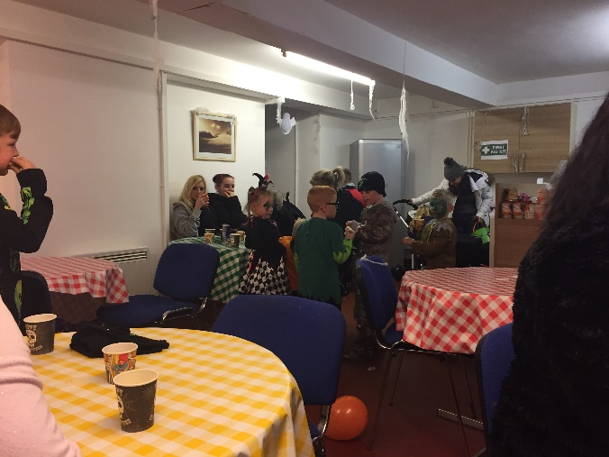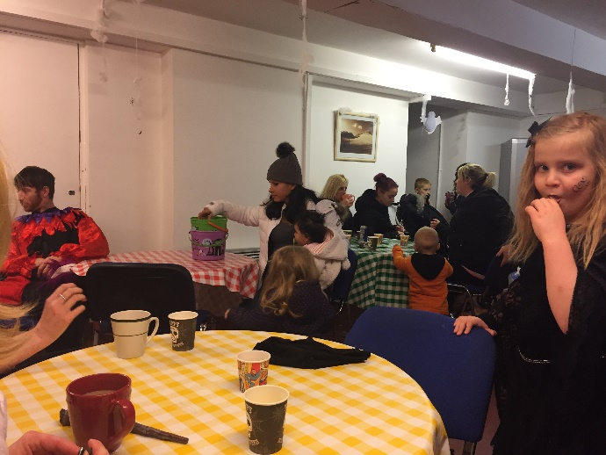

The Fidra Kitchen Christmas Lunch was a huge success. A massive thank you to everyone who attended. Especially the Tesco team who kindly supplied the Christmas dinner and decorations. Also a huge THANK YOU to Tesco for their weekly food donations via Cyrenians Fareshare, supplying staff to paint and decorate the Kitchen and for all their support over the past year.

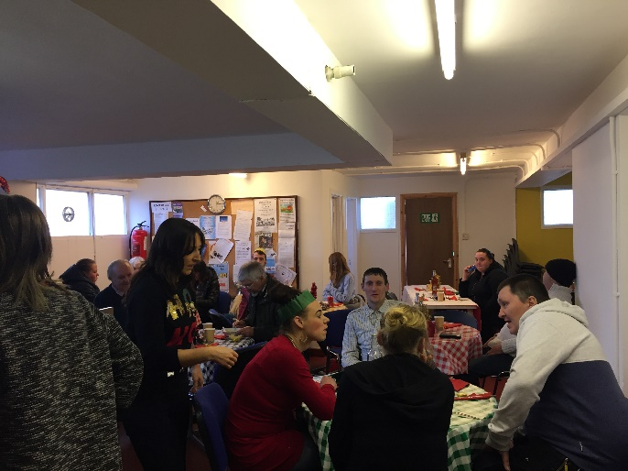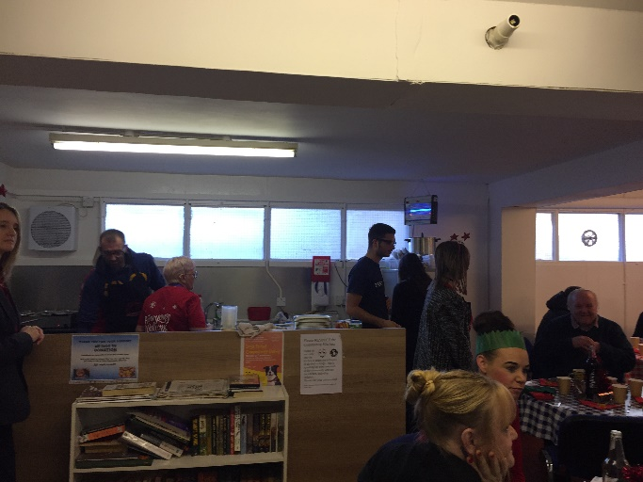

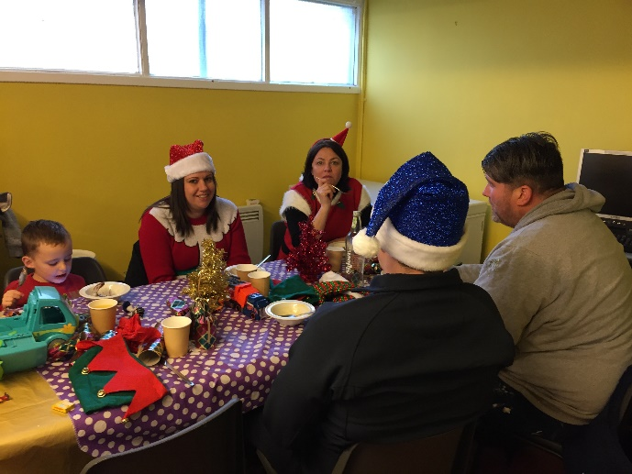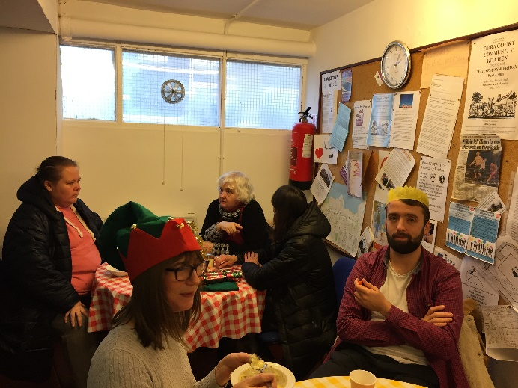

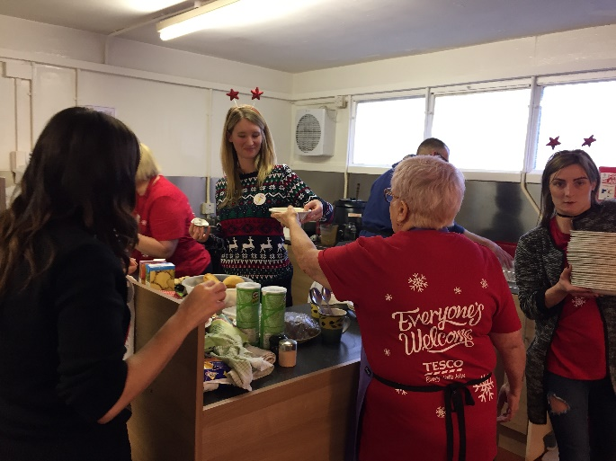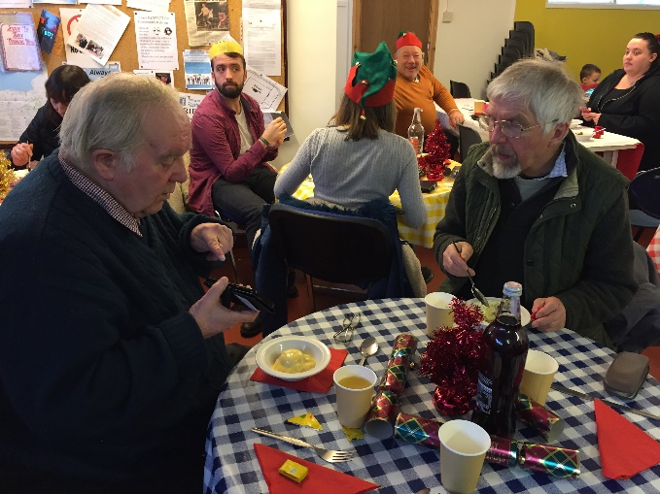

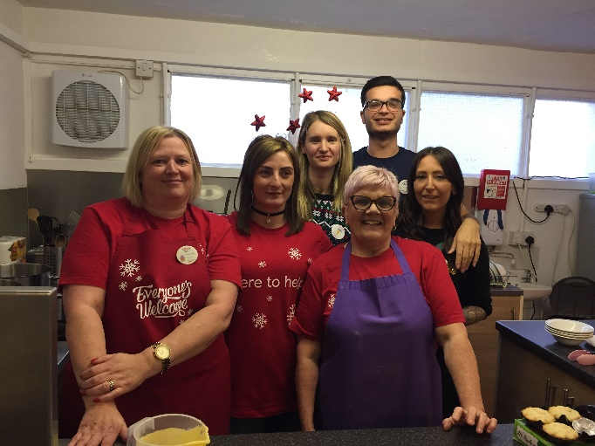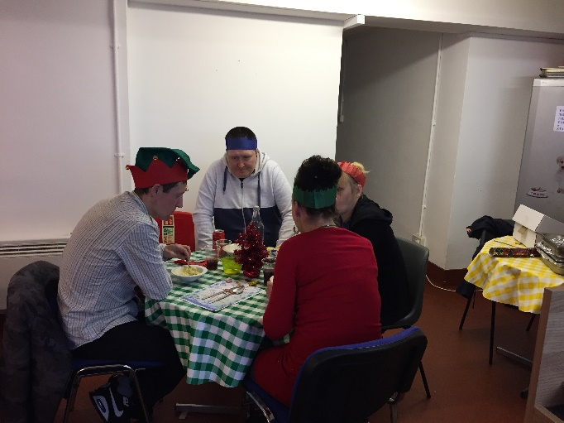

Fidra Court Kitchen update:
In 2018 Fidra Kitchen will be undergoing some changes! Work will start on the garden to create a growing space and garden for tenants and residents of Fidra Court. We will be working on expanding the Kitchen and opening the community room for meetings, activities and a safe and relaxing place for residents to use.
Environment:
We have been working closely with the City of Edinburgh Council Concierge service and the Environmental health and recycling team to tackle the rubbish and dumping of refuse around the high rise flats. In the new year we are holding a community environment and recycling meeting at Fidra Court on the 18th of January from 1400 to 1600. The litter pick group have taken time off over the cold period but are all prepared for the New Year with printed hi-viz vests, protective gloves and litter pickers.
Community Shed – The community shed project have been supporting Community Conversations and Fidra Kitchen volunteers by providing their expertise, knowledge and people power to build a Fidra Court Community Kitchen sign and planning the landscaping of the garden and growing area.
Community Wellbeing:
After many discussions and meetings over the past few months to understand the issue, the community forum and residents highlighted the need to provide a service for young people living in the area. To address and focus on this priority we have appointment 2 part-time Neighbourhood Youth Workers who are starting working with us in the New Year. We would like to welcome David Graham and Louise Lothian onto the Community Conversations team and look forward to seeing them out and about in the New Year.
2018 and beyond!
We have several ideas and projects who want to bring their ideas to the Community Forum in 2017. SheScotland are hoping to present their project working with local women in Muirhouse. We are also meeting with a local resident who wants to start up a youth project supporting young people through the transition between primary and secondary school and providing a youth club in Muirhouse. The City of Play visited us and hope to work in partnership with us all on community events and providing exciting and adventurous play experiences. So it looks like a busy and exciting year ahead!
All the staff and volunteers from Peoples Health Trust Community Conversations project and Community Renewal wish you a Very Merry Christmas and Happy New Year.
See you all in 2018!
Laura

