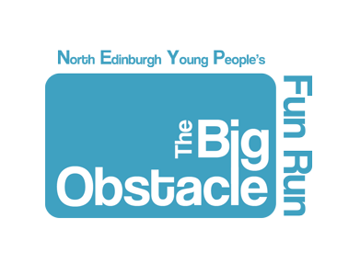
Agency Information
Pack
Sunday 2nd July 2017
Inverleith Park

The Big Obstacle 4k Charity Fun Run

What?
4k charity fun run with obtacles throughout.
When?
Sunday 2nd July 2017
Where?
Inverleith Park.
Meet at Royal Botantics entrance
Street name: Arbroetum Place
Why?
We want to:
- Encourage young people to get active
- Raise the profile of local youth organisations

- Give local organisations the chance to fundraise

- Bring the community together
How?
Speak to a youth worker in your organisation.
Sign up by Friday 23rd june 2017
Centre closes by 7pm if you need to contact someone on this date
Cost to enter: Individual £5, team of 5 £20
You will get a medal for taking part, a certificate and a healthy snack at the end of the race.
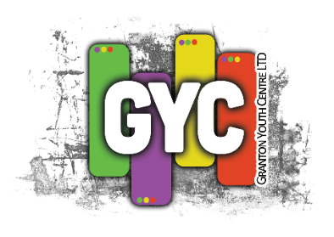
Both teams and individuals are encouraged to raise sponsors for their chosen agency/charity.

If you are interested and want more information contact
thebigobstacle@grantonyouth.com

Granton Youth Centre
3-11 West Granton Road
Edinburgh. EH5 1HG.
Tel: 0131 467 5854
www.grantonyouth.com
INDIVIDUAL REGISTRATION FORM
Name | Address – including postcode | Email + Contact Number
Emergency Contact – name and phone number | Medical Conditions Race – e.g. allergies / asthma
11-17 Run
18+ Run
All participants in The Big Obstacle 4k Charity Fun Run are required to complete and submit the following form. Granton Youth Centre cannot take responsibility for the supply of any wrong information within this process. If you require any further information regarding this event please contact
thebigobstacle@grantonyouth.com and allow 2 working days to respond
Individuals are charged at £5 per entry

Signature: ________________________ Date: _________________

Please note: this event is covered by Public Liability Insurance and not Personal. Personal Liability Insurance if required must be arranged by the individual
Granton Youth Centre Ltd
Company Number: 340606 - Scottish Charity Number: SCO31622.

Granton Youth Centre
3-11 West Granton Road
Edinburgh. EH5 1HG.
Tel: 0131 467 5854
www.grantonyouth.com
ORGANISATION REGISTRATION FORM
All organisations participating in The Big Obstacle 4k Charity Fun Run are required to complete and submit the following form, ensuring that organisation team insurance and planning information is in place and being adhered to. Granton Youth Centre cannot take responsibility for the supply of any wrong information within this process. If you require any further information regarding this event please contact thebigobstacle@grantonyouth.com and allow 2 working days for a response
Organisation Name | Lead Contact | Medical Conditions Within the Team – e.g. allergies / asthma
Address | Email + Telephone Number

Teams for Event – complete below to indicate the details of who will take part in your team, young people or adults. Teams can be up to 5 people and individuals can be sponsored to participate. The cost of entry is £5.00 per person or £20 for a team of 5.
Team – please list up to 5 young people, between S1 and 17 years.  1.  2.  3.  4.  5. | Adult Team – please list up to 5 adults, aged 18 and above.  1.  2.  3.  4.  5.
Please note: organisations can put more than one team of adults and/or young people into the event.

The Big Obstacle 4k Charity Fun Run is being run to support local community groups to raise funds and awareness locally of the work, programme and services being delivered. Please tick the following boxes ensuring that you have your own public liability insurance for the participants in place
□ Yes we have our own Public Liability Insurance in place (please tick)
□ Yes we have signed consent forms for each participant (please give a copy to us before the day)
Granton Youth Centre Ltd
Company Number: 340606 - Scottish Charity Number: SCO31622.

