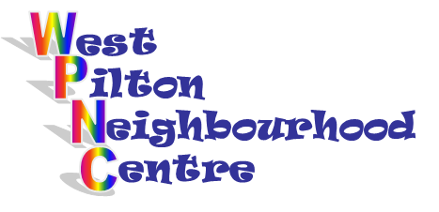The Management Committee of
Pilton Central Association
and
West Pilton Neighbourhood Centre

are holding a Joint

ANNUAL GENERAL
MEETING

at
West Pilton Neighbourhood Centre
19 West Pilton Grove, Edinburgh
on
Wednesday 24th May 2017
starting at 5.30pm

There will be two speakers:
The Way Forward for the PCA
The Future of the WPNC

All Welcome
Light refreshments will be provided

Please contact Linda Chandler on 0131 551 3194
Or email linda.chandler@ea.edin.sch.uk
if you are able to attend

