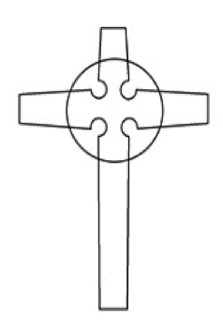
£5K
give away
THE OLD KIRK AND MUIRHOUSE PARISH CHURCH
Your Voice Your Choice

Do you have an idea that will make our local community a better place for everyone?
Do you need £200 to £1,000 to put your idea into action?
If your answer is YES then ‘Your Voice Your Choice’ is the opportunity for you to make your project happen.
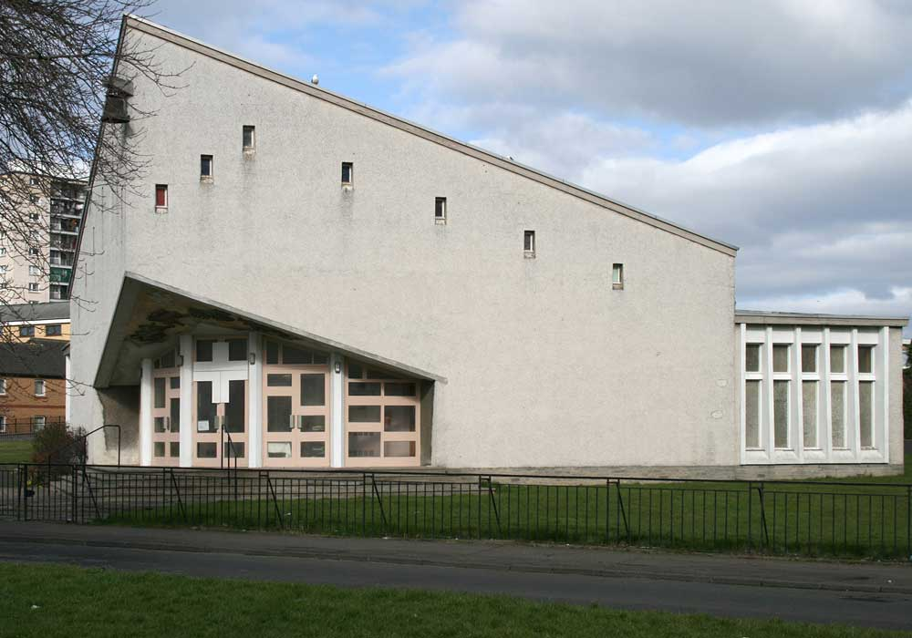

Deadline for applications is
Friday 17th March 2017.
If you need information or assistance with the application please contact
Rev Stephen Ashley-Emery
Email SEmery@churchofscotladn.org.uk
Mr Malcolm Dickson Email malcydick@talktalk.net
A Community Together Event

The Scottish Government have set aside £5,000 for community improvement in the Parish of the Old kirk and Muirhouse (West Pilton and Muirhouse) and want to put YOU in control of how it’s spent.

The ‘Your Voice Your Choice’ Initiative lets the local community decide for themselves which projects are needed in their area.

What can you apply for?
We need your ideas for projects that will:
- Benefit as many people as possible from across the community.
- Help to make the Parish of the Old kirk and Muirhouse a better place for everyone.
- Add value to existing projects.

Any project large or small is welcome.

Whether you want to organise a healthy living project, a community safety idea, a lunch club for older residents, a community art project, the only limit is your imagination and your project or idea happening within 12 months.

Who can apply?
Any local community, voluntary or non-profit organisation – even informal groups– can apply for funding from £200 to £1,000 to put ideas into action.

Any individual or un-constituted group provided their bid is supported by a constituted group can apply. This means the constituted group manages the money and the un-constituted individual or group delivers the project.
How do you apply?
To apply for the funding you must return this form before 6pm Friday 17th March 2017. If your idea fits the criteria, the community will get to vote for the best ideas at an event to be held on Saturday, 25th March 2017, 10am.

Event
The event will be held at The Old Kirk and Muirhouse Parish Church, doors open at 10am. At the event you will be required to present your idea to the community for 3 minutes . Those in attendance will then vote on all the applications and a decision will be made on the day.
Refreshments will be provided.

Your Voice Your Choice
REGISTER YOUR IDEA: APPLY TODAY
Your full name:
Address where we can write to you. (Your own address or the address of the organisation you represent)

Your postcode:

Telephone number:
Email:

Alternative contact name:
Telephone number:
Email:

If you represent an organisation what is its’ name?

What is the name of your project/idea?

Briefly describe the project you would like funding for (up to 150 words):

What is the particular need and how will the project address it and make the community better?

How many people do you think will benefit from your project (as accurately as you can estimate it)?
For example this could be the number who will attend a lunch club weekly

How much money do you require and what will you spend it on?
Please give a breakdown of the costs of your project and when you expect to spend the money by. For example: equipment costs, running costs, staff time.

Please indicate the expected start and end date of the project.
Please detail any other funding sources and if it has been confirmed.

Please return this form via email to: tokandmchurch@gmail.com

or post/hand it in to: The Old Kirk and Muirhouse Parish Church,
42 Pennywell Gardens, Muirhouse, EH4 4PE.

DEADLINE FOR APPLICATIONS: 17th March 2017

The Old Kirk and Muirhouse Parish Church is a Scottish Charity No. SCO 06457

