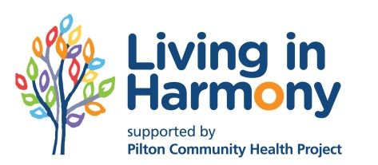

Your views about the Living in Harmony forum
If you could take a moment to answer these questions about the forum it would really help us to plan upcoming meetings and think about our work.
As a reminder, the aims of Living in Harmony are:
To make services in North Edinburgh more accessible and make sure Black and Minority Ethnic people have their voices heard in the community
To help local residents to feel more confident and skilled and have more opportunities for integration
- Do you live or work in the area? If you represent an organisation, which one do you represent?

- What do you find most helpful about Living in Harmony forum meetings?

- Are there other things we could be doing at the meetings to work towards our aims?

- What would put you off coming to a meeting?

- If you work for an organisation, how does being involved in the Living in Harmony forum help you to make your services more accessible? Have you done anything specific to reach out to BME communities in the area over the last year?

- If you are a resident in the area, why is Living in Harmony important to you?

- What would you like to see the initiative do in the coming year? How would you like to be involved in this?

Thank you for taking the time to fill this survey in. Please leave contact details if you are willing to be contact by Living in Harmony in the future.

Name ___________________________________________________________
Email ___________________________________________________________
Telephone number_________________________________________________

