Together we can change attitudes and perceptions towards mental health issues!  It’s our aim to help individuals and companies tackle the problems created by mental health issues ‘head on’ and attempt to change the way these difficulties in the workplace are perceived, understood and tackled.  Whether you are an employee, concerned friend, a line or HR Manager or even the business owner we can offer you the support and advice you need to resolve mental health issues at work.  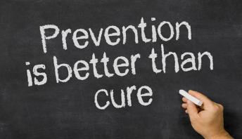  - Essential to a businesses’ performance  - Critical to managing business risk  - Vital to safeguarding the responsible management of people  Prevention and early intervention! |  | TAKE ACTION TODAY!  Our services are available to individuals and organisations either for a one-off cost or on an ongoing basis.  FOR MORE INFORMATION  VISIT  www.mhscot-consultancy.co.uk  EMAIL  hello@mhscot-consultancy.co.uk  OR CALL  0131 618 8244  @MHScot_Consult  facebook.com/MHScot |  | Mental Health is everyone’s business!  Scotland’s first Social Enterprise tackling stress prevention and early mental health intervention in the workplace.  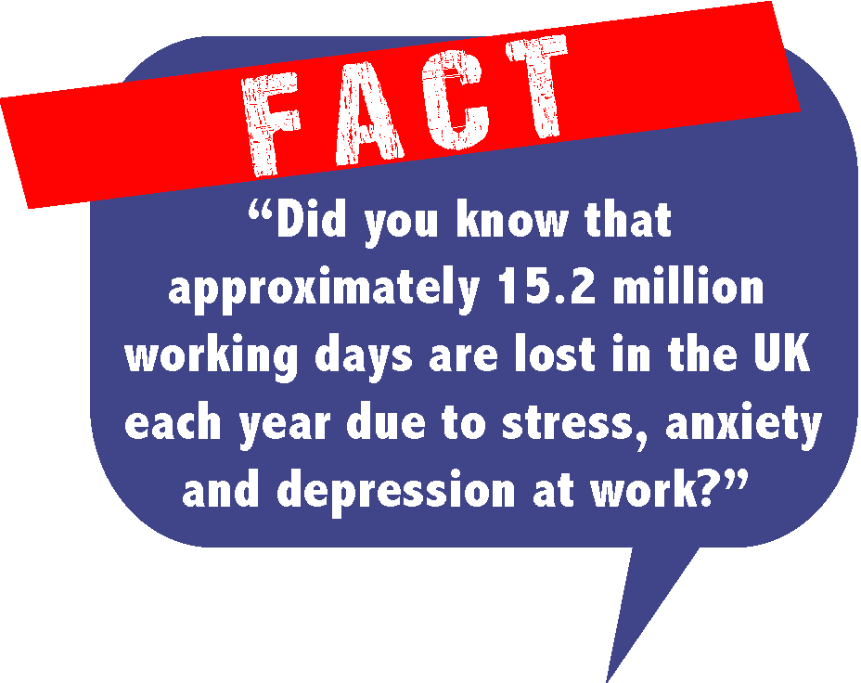  Talk about mental health issues  without fear of stigma. Don’t ignore the issues, turn to us for helpful and constructive advice.  READ ON TO FIND OUT HOW MHSCOT CAN HELP….  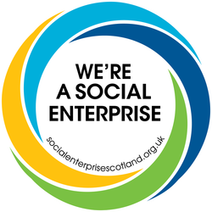
WHAT WE DO  We provide the ongoing ‘wellbeing’ and ‘mental health’ support to your staff.  We identify required policy changes in relation to staff wellbeing.  We offer confidential ‘stress audits’ and ‘mental wellbeing’ surveys.  We enable your HR Department and/or people managers to reduce absenteeism and presenteeism from work due to stress related difficulties.  We will train ‘workplace wellbeing’ champions in your organisation who can then be our first point of contact for any ongoing problems. |  | WHY MHSCOT?  - With over 25 yrs experience in the mental health profession we can show you how to reduce the negative affect that mental health issues have in the workplace and create positive steps to overcome them.  - We tailor bespoke solutions to tackled work based problems.  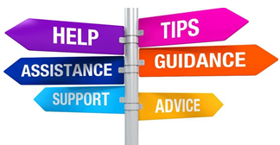  - Our strategies will help tackle reduced productivity issues, absenteeism, presenteeism and better ‘wellbeing’ working practices.  We provide better results for you and your business, increasing staff morale and improvements in overall staff wellbeing and resilience. |  | Wellbeing in the Workplace  Vested Interests  The HR/Line Manager wants to know what to do about any wellbeing problems staff are having in their workplace and be able to recognise the issues, signs and symptoms.  The Business Owner has a similar vested interest to the HR Manager, but for them, how they deal with the issues can make or break the business performance.  The Employee is the one most directly affected by their difficulties; the one living with day-to-day stress, depression or anxiety; the one that really needs someone to talk to.  The Friend/Colleague knows the person struggling at work. They’re stuck in a difficult position. They would need somewhere to go to find out about the signs that their friend is displaying.

