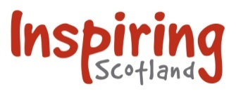

**WEST PILTON PARK CHALLENGE PROJECT**

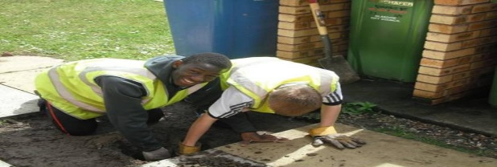

**Start date:** 10th October

**Duration of programme:** 5 weeks

**What is the Challenge Project?**

Action for Children’s community-based youth skills programmes are aimed at 16-19 year olds who experience considerable disadvantage in accessing sustainable employment.

The challenge programmes are designed to support young people who have just entered into the early stages of employability support. This unique training opportunity not only improves learner’s confidence, employability and life chances; but, also encourages them to take a definitive pride in contributing towards making positive improvement towards an identified community issue.

Each of the learners will be presented with an opportunity to learn employability skills and gain new practical construction experiences to help enhance their prospects of securing further employment, training and education opportunities.

**West Pilton Park Project**

We have teamed up with Robertson Group Ltd and The Pilton Community Health Project to complete the Challenge programme in West Pilton Park. Our team of skilled staff will work with trainees to reclaim the woodland areas within West Pilton Park. Through various landscaping activities participants will be supported to complete a number of practical tasks such as woodland thinning, clear undergrowth, remove lower branches (crown lifting) and lay bark/wood chippings to supress weeds.

**Is the Challenge programme for me?**

The Challenge programme is a great starting point for any young person looking to explore the construction industry. Due to the programme being hands on participants will get to work on a real construction project as well as gain an insight into health and safety when working within the construction sector.

**What to expect from the Challenge Programme**

* Attendance – 4 days per week (Monday to Thursday). Hours of attendance will be 10:30am - 3:30pm
* Participants will be paid a training allowance of £55 per week and travel expenses if needed
* Each young person is assigned a dedicated key worker to support them through all aspects of the programme
* On successful completion of the programme young people will be supported to secure opportunities within Action for Children’s other construction related training programmes that start in the New Year
* Through care support will be offered to participants who wish to explore other sectors

**How to apply**

* Completed application forms to be sent to [nicola.raine@actionforchildren.org.uk](mailto:nicola.raine@actionforchildren.org.uk)

****Do not hesitate to contact Nicola on 0131 661 7828 or 07545701036 if you would like to discuss anything