Royston Wardieburn Community Centre
11 Pilton Drive North, Edinburgh, EH5 1NF
Phone 0131 552 5700
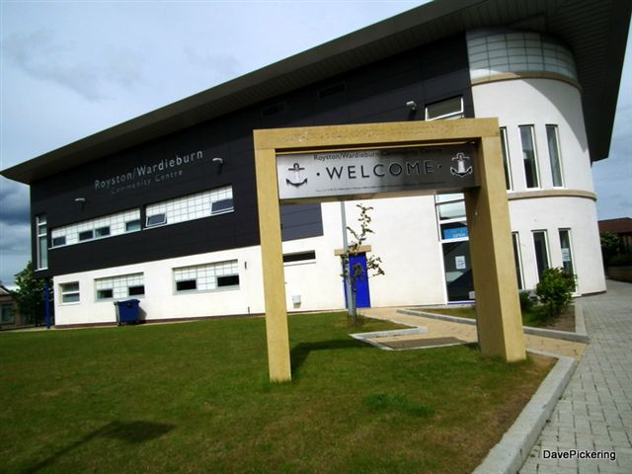

ALL WELCOME
Annual General Meeting
Wednesday 5th October 2016
12-2.00pm
Guest Speaker
Lunch Provided
Creche available but must be booked in advance

