Tenants and Residents in Muirhouse (TRIM)
31 May 2016
Present : RP, BB, AR, HF, DA, EC, JD, BO, JH, NW,
In attendance: MR North Local Office
Apologies : MP Ben McPherson, Cllr Cammy Day, Cllr Vicki Redpath , KL, KM, PH, KF
Previous Minutes: JH and JD confirmed true and accurate
Matters Arising :
No matters arising
Correspondence : Bank statements March and April filed.
ETF Membership form – To be action asap
Finance :
No change to finance from last meeting
Environmental :
JD provided the group with an excellent update on Linear Pal and the football pitch.
Scottish Water have declined to allow a pipe to be put in to their drain and as a result the council are testing “ Soak away system” – This is being tested at the moment and we hope to have a update over the coming weeks. The board was pleased with this update and all hope it works well.
JD and BB discussed the issue with dog fouling, many residents use the football pitch as a dog toilet and it is often unplayable due to the mess. HF suggested getting local kids involved to create posters and put them up around the area. Group to meet next week to discuss this in more detail.
Friends of Linear Park Fully registered with ECC since November 2015
JD had discussed that he had went on a walk about with North Local Office and local Cllr, they have identified and came up with an action plan. The board agreed that FOLP need to start to take action, look at funding, get plans in place and take steps towards getting a green flag. JD and RP agreed to meet next week and walk the park. MR from NLO said that JJ from NLO would come along and assist where possible. HF suggested that all those on FOLP taken action; meaning walked the park, photographed the area and highlighted the issues.
It was also discussed as a group that we could approach local garden groups, MHA, and Local Contractors to ask them for support.
RP also suggested making contact with the likes of Morrison’s and Scottish Gas once we have a plan in place and ask for their support.
MR suggested getting new people involved in the group
Fly-Tipping
DA and BB both spoke very passionately about the fly tipping, whilst it was a sight for sore eyes, BB stated that we have some of the poorest residents and they can’t afford the charge. AR suggested that ECC offer Free uplifts again, HF and RP advised this was very unlikely. The group were then shown a picture of the disgrace Fidra Court * See Below* - This is one of the newest upgraded areas and it is in such a mess. BB and EC also highlighted that Morrison’s trolleys are an issue. RP agreed to make contact with them to highlight this.
A very good group discussion taken place and we all agreed that Friends of Linear Park needs to move forward. JD asked that we arrange for Cllr LH to visit the park and have a walk around with us.
Longer term we spoken about how a social enterprise could manage the green spaces
This is one of the newest parks and it’s a disgrace and it will only get worse if we leave it says JD
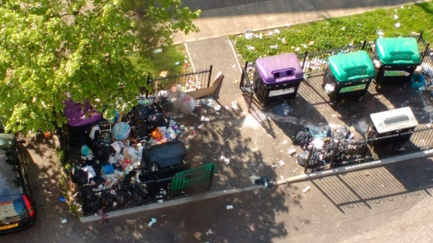
Improving Pennywell and Muirhouse
JD attended the IMP meeting last week and a discussion taken
HF made the board aware that the church had to move their compost heap which has been there for years as the council think the youths are using that to climb over the 2 meter high boards to access the football pitch at CCHS. The youths have accessed the pitch using the path since the school opened; this has now been closed off. Concerns have been raised as the inevitable will happen. JD confirmed that the IMP group had discussed this.
MR will email the plans and road traffic plans to board members, as questions were raised again about the sheer volume of HGV’s that we can expect and the proposed routes.

Community Shop Report :
JH gave the board a comprehensive update
- Recently the community shop has had 2 new volunteers join, David Aris who is well known around North Edinburgh and Kirsty who was one of the original volunteers.

- Volunteers are keeping track of how many people come into the shop, This will allow us to evaluate how many residents use the shop.

- This Thursday the shop will be closed to allow work to be done in the back area, We would like to Thank Robert McKenzie from St Pauls Muirhouse (Student Accommodation)

- We are looking into getting other local groups and organisations involved in the shop once the work is all completed.

- Volunteers are also looking in to – cook and taste sessions, Dr bike sessions and lots more. Once again when works are completed

- The manager special went down well so we are also looking into bringing this back and to hopefully change it every second week

If anyone has any suggestions for the shop just let me know or pop into the shop and have a chat with one of our volunteers.

RP added that he was delighted to see that KL is being awarded for her volunteering at a ceremony next week. From all at the board and community shop well done
Any Other Business :
Chairman RP made the board aware that an allegation was made against TRIM, he had received a call from PS manager of North Local Office, PS had concerns that TRIM was connected to the SNP party. RP made it clear to PS that TRIM was not affiliated to any political party unlike other groups in North Edinburgh. RP discussed with the board that TRIM board had been photographed with many political members and is most certainly not connected to any particular group. The board agreed that what members do outside TRIM is entirely up to them.
All present discussed the lack of support from Councilors, since TRIM started we have only seen two Cllrs who are Cllr Redpath and Day. It is very disappointing that we are one of the most active groups in North Edinburgh yet Cllrs don’t attend.
Chairman did thank MR from NLO for attending in her own time.
Next Meeting – 28th June 2016 at 7pm within Muirhouse Millennium Centre

