This is a programme of activities in the community centre for adults.
The session will start with a light lunch of soup, sandwiches, cake, tea or coffee.
After lunch choose which activity you would like to try

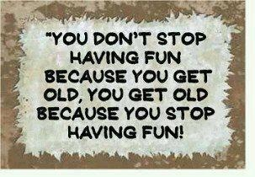

Royston Wardieburn Community Centre
11 Pilton Drive North Edinburgh, EH5 1NF
0131 552 5700

FREE
7 week programme for adults
Programme Details
Each Session starts with light lunch 12noon – 1.00pm Activities Start 1.00pm – 2.30pm
Week 1 - Wednesday 13th April 12noon-2.30pm
Welcome/Introduction/Consultation meeting
Week 2 - Wednesday 20thApril 12noon-2.30pm
Social History Film – share your memories with others
Flower arranging – create a beautiful display
Dominoes, Cards, Carpet Bowls, Badminton, Read, Chat
Week 3 - Wednesday 27th April 12noon-2.30pm
Social History Film – share your memories with others
Flower arranging – create a beautiful display
Dominoes, Cards, Gentle Exercise, Read, Chat
Week 4 - Wednesday 4th May 10am – 4.00pm
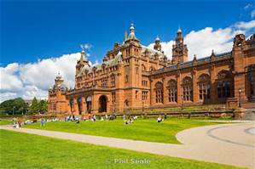
Trip to Kelvingrove Gallery, Glasgow (Places limited)

Week 5 – Wednesday 11th May 12noon-2.30pm
Social History Film – share your memories with others
Hand/Foot Massage – relax and enjoy
Dominoes, Cards, Carpet Bowls, Badminton, Read, Chat
Week 6 - Wednesday 18^{h} May 12noon – 2.30pm
Social History Film – share your memories with others
Picture Making – Create your own picture
Dominoes, Cards, Line Dancing, Read, Chat
Week 7 – Wednesday 25th May – 10am – 4pm
Trip to the Kelpies or Bo’ness Railway or People Palace
(Places limited. Weather permitting)
