PUBLIC MEETING

THE PRENTICE CENTRE
1 GRANTON MAINS AVENUE

WEDNESDAY 9TH MARCH
7PM
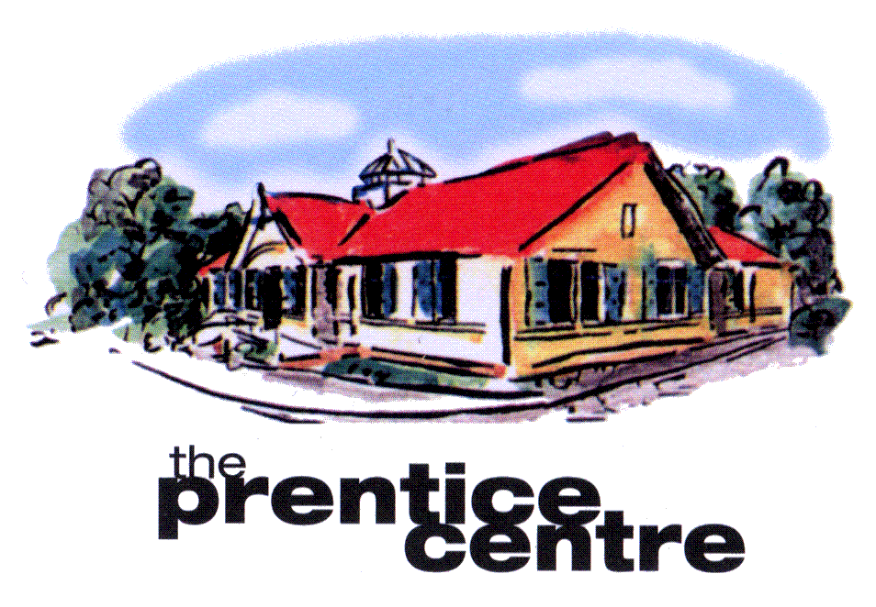

THE PRENTICE CENTRE IS
UNDER THREAT OF CLOSURE

PLEASE COME ALONG TO THE
PUBLIC MEETING & LET LOCAL POLITICIANS KNOW HOW YOU FEEL

ALL WELCOME

