Volunteer for
PILTON EQUALITIES PROJECT
Make a difference in your local community
MINIBUS VOLUNTEER
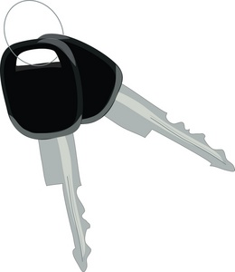 DRIVERS REQUIRED

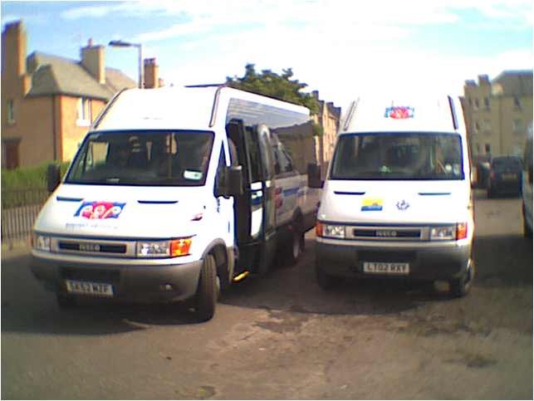
D1 required on licence, for more information contact:
Elaine Anderson at Pilton Equalities Project on 315 4466 elainepepequalities@hotmail.co.uk

