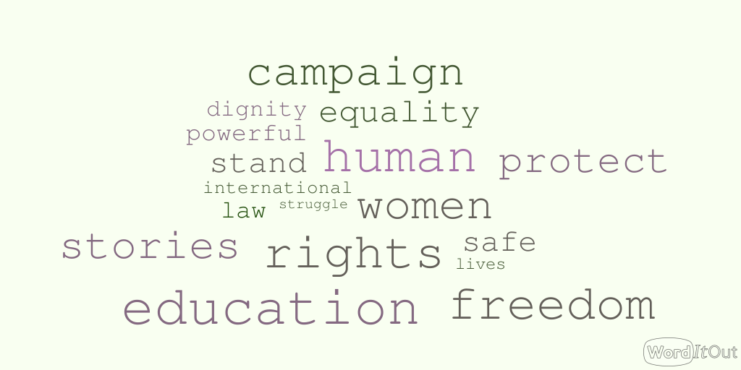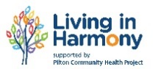

**North Edinburgh Supports Syrian Refugees**. Supplies needed!

We need warm outdoor clothing; gloves, jackets scarves etc.

Basic toiletries, toothbrushes etc

New underwear

Bring items on the day.

**Women’s International Group**

**Women Getting Together**

**Making a Difference**

Royston Wardieburn Community Centre

Community Learning and Development

*A follow up to the event in June organised by the* Women’s International Group, *where* *70 local women celebrated the success of local campaigns. This event will look at the issues of home, human rights, immigration and asylum. What can our community do to make a difference? Join us for a discussion.*

10am -12.30 pm

Films, discussion, free lunch

Free crèche *(book in advance)*

**All women welcome**

**Phone Lynn 0131 552 5700 or Rachel 07891525663 for more information or to book a creche space or transport**

**North Edinburgh Timebank**

**Thursday 24th September**

**10am – 1pm**

**Royston Wardieburn Community Centre**

Pilton Drive North