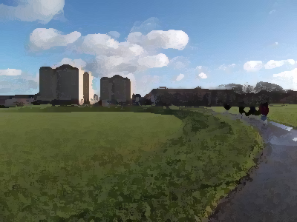 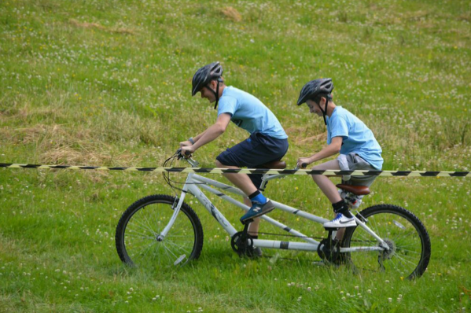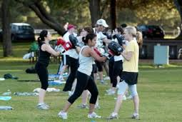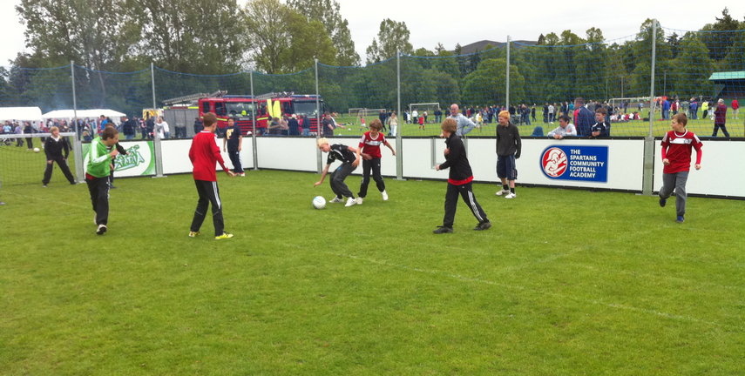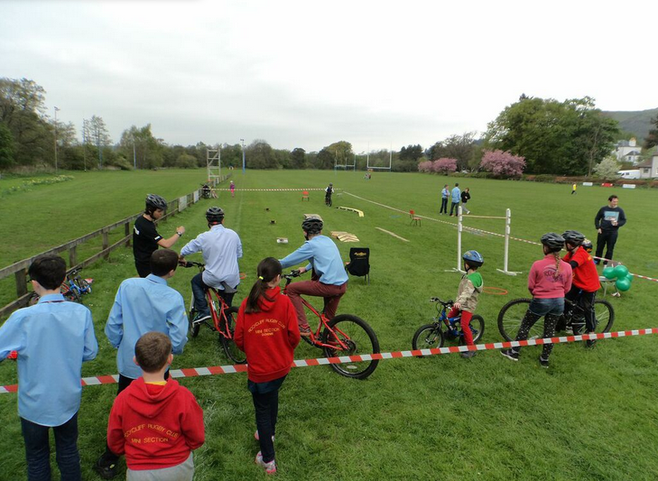

**Saturday 13th June 12-4pm West Pilton Park**

**My Adventure Spartans**

**Bike Assault Course Portable Football**

**Kabo**

**Boxing**

**Free For Everyone**

**More Info Contact Lianne 0131 551 1671 or James 0131 332 7132**



**Peter Airlie**

**Cycle Development officer**

**www.myadventure.org.uk**