**Royston Wardieburn Community Centre**

**Family Fun Day**

**Saturday 30th May 11- 3pm**

**Raffles, Tombola’s, Bouncy Castle, face painting, Water Slide, Bungi Run, Soft Play,**

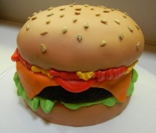**Familiar T.V. Characters,**

**Table Top Sales,**

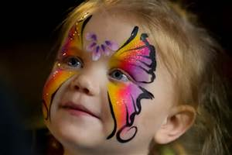**Food & Refreshments available**

**&**

**Music throughout the day.**

[](http://www.bing.com/images/search?q=Soft+Play+Balls&FORM=IRTRRL)[](http://www.bing.com/images/search?q=Coffee+Clip+Art&FORM=IRTRRL)



**There will be a small entrance fee and Table Hire**

