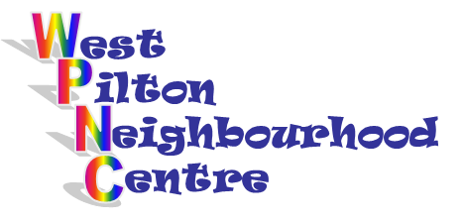
19 West Pilton Grove,
Edinburgh, EH4 4BY
Tel: 0131 551 3194
Email: cld-westpilton@ea.edin.sch.uk

Friday 17th April
11.00am-3.00pm

Call into the Centre or telephone 551 3194 to book a table
Tables are £2 large, £1 small or £1 if you bring your own.

