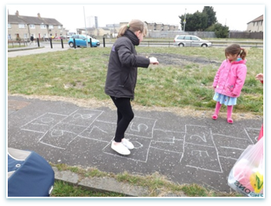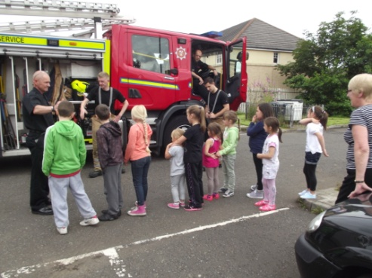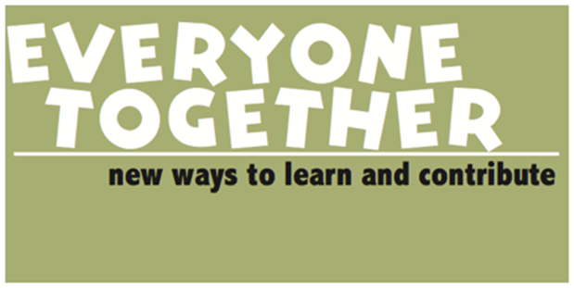

Big changes are happening in Scotland about how families who need support are offered it. This is called **Self Directed Support**. The idea is that families and communities can have more say and control over the types of support they are offered.

Total Craigroyston and Muirhouse Link Up are working with Diversity Matters to run a course for everyone involved with children and families in Pilton and Muirhouse - social workers, community workers, support workers, people who need support, families, friends, neighbours, local community leaders and others.

We know that there is a huge variety of skills amongst us, families,

communities and workers. By sharing skills and working together we can

help families live well.

Come and find out how the new changes can help us do things better.

The course will run from 9.30am to 2pm in

**North Edinburgh Arts Centre** on the following dates:

**wednesday 29 april -** Building the right kind of relationships

**Wednesday 6 May –** What do we need? Identifying local services

**Wednesday 13 May –** Creating local networks to help us work together

**Interested?** Contact Tracey Devenney at Total Craigroyston for more info and to book a place: Tel 529 5073; email [tracey.devenney@edinburgh.gov.uk](mailto:tracey.devenney@edinburgh.gov.uk)

***Everyone Together*** has been developed by Diversity Matters and is funded by the Scottish Government to help develop the use of Self Directed Support

We have run 12 events in the last year in different parts of Scotland, read more at ***everyone-together.org***