NEW
TAI CHI CLASSES

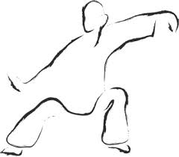

New gentle exercise class for adults of all ages
Qualified instructor
Every Friday 11am – 12noon
Cost: £2.00
Royston Wardieburn Community Centre
11 Pilton Drive North
Edinburgh EH5 1NF
0131 552 5700

