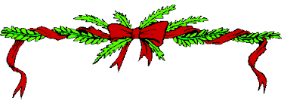
Council Cancels Christmas
£67m to be slashed from your services over the next 3 years.

Public Meeting
Help stop the cuts
Tuesday 9th December 2014
Royston Wardieburn Community Centre
6.30 -8.30

Crèche provided
Save Our Services
Organised by Women’s International Group (WIG)

On the first day of Christmas
The Council said to me ……
No library services
No leisure centres
Increase in charges
Reductions in policing
Community centres closures
No swimming pools
No bus passes
Less nursery places
Less bin collections
More fly tipping
Parks growing wild
More food banks
People growing hungry
More poverty.
Join the campaign – fight the cuts
There is always an alternative

