LOOPS Local Opportunities for Older People is a new service run by Volunteer Centre Edinburgh
Live in North West Edinburgh or South East Edinburgh?
Aged 65 or over and want information on what is going on in your vicinity?
Want to link in to your local community?
Want to be with people?
What to find out what is happening near you?
Want to try something new?
Want to start an activity you used to enjoy?
Let us help you join events that are going on locally
How can we help you today?
Take action….
Chat with a friendly volunteer at the Volunteer Centre Edinburgh on 0131 603 8311 between 10am to 2pm Monday to Friday and we let you know what is happening near you that you may enjoy.
We will also send out information to you on activities email loops@volunteeredinburgh.org.uk

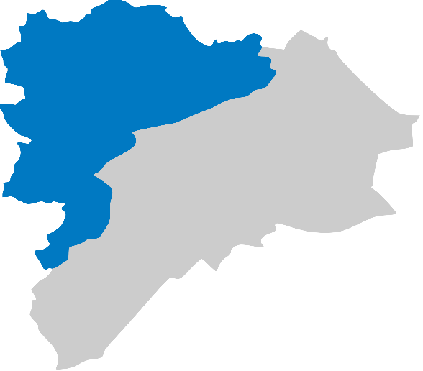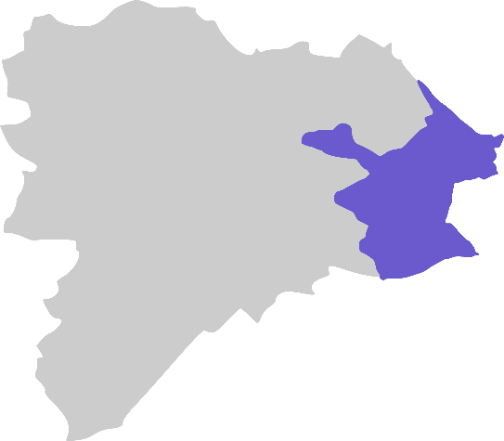

Heather Yang
LOOPs Development Officer
0131 603 5144 07505306192 heather.yang@volunteeredinburgh.org.uk
Volunteer Centre Edinburgh 3rd Floor 24 Torphichen Street Edinburgh EH3 8JB
0131 225 0630

