WHAT’S BEST FOR SCOTLAND?
REFERENDUM DEBATE
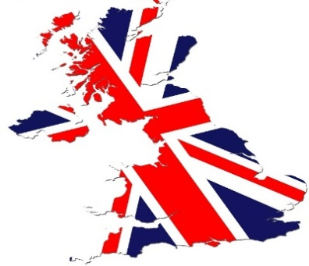
THURSDAY 26TH JUNE 2014
6.30 – 8.30 pm
ROYSTON WARDIEBURN COMMUNITY CENTRE
11 Pilton Drive North Edinburgh EH5 1NF

ALL WELCOME
Crèche & Refreshments provided

Don’t leave it too late to join the debate.
REFERENDUM DEBATE
Concerned about pensions, jobs, nuclear weapons, passports, welfare benefits, public services, the pound….?
Join us on 26 June
This is your opportunity to raise your concerns and to get answers to your questions.

This event has been organised by North Edinburgh Women’s International Group.
For further information, contact Royston Wardieburn Community Centre on:
0131 552 5700

