

Thank You Sainsbury’s Blackhall for fixing our Youth Club!

**From boarded up broken glass windows… to Perspex making our Club light and bright again**

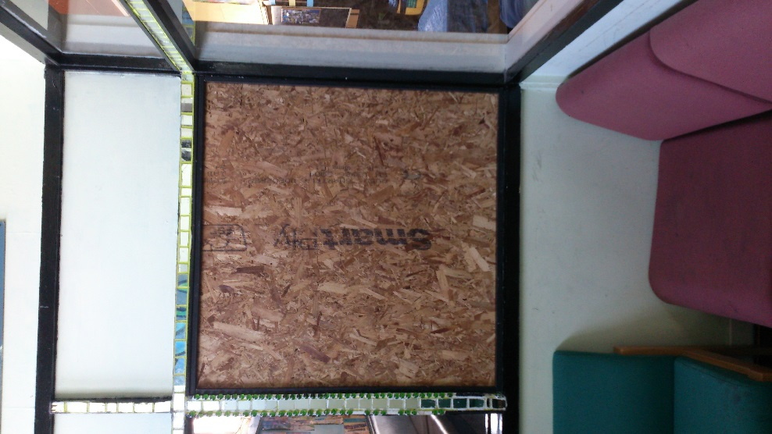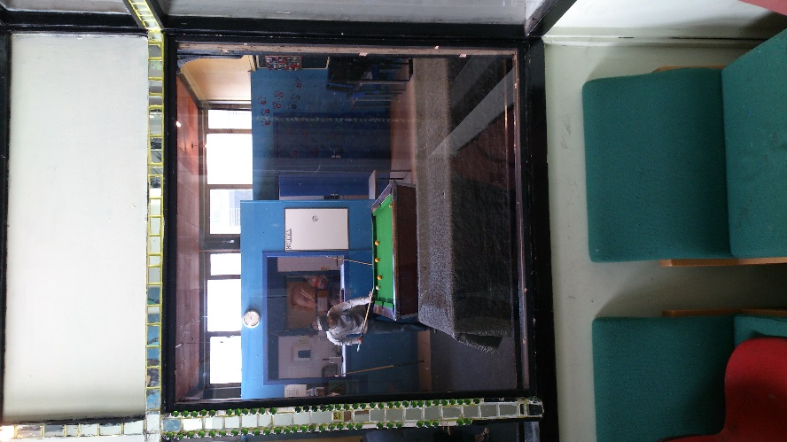

**A hole in the cupboard housing our mains electricity boarded up and safe**

**Our disintegrating Sports Hall ceiling patched up and safe**

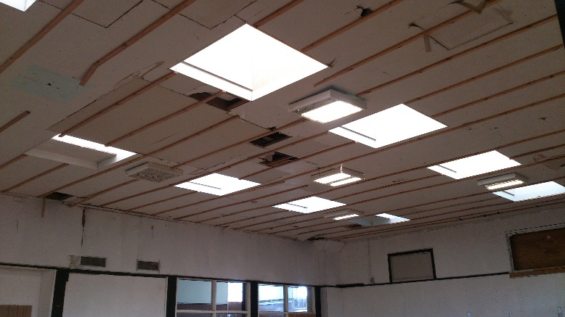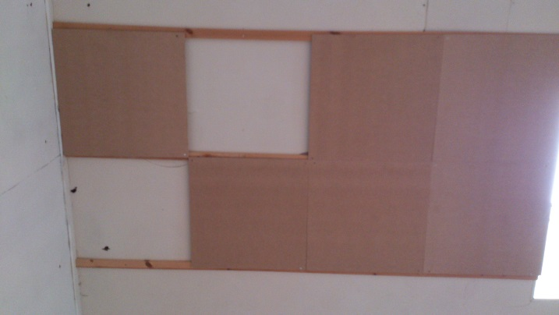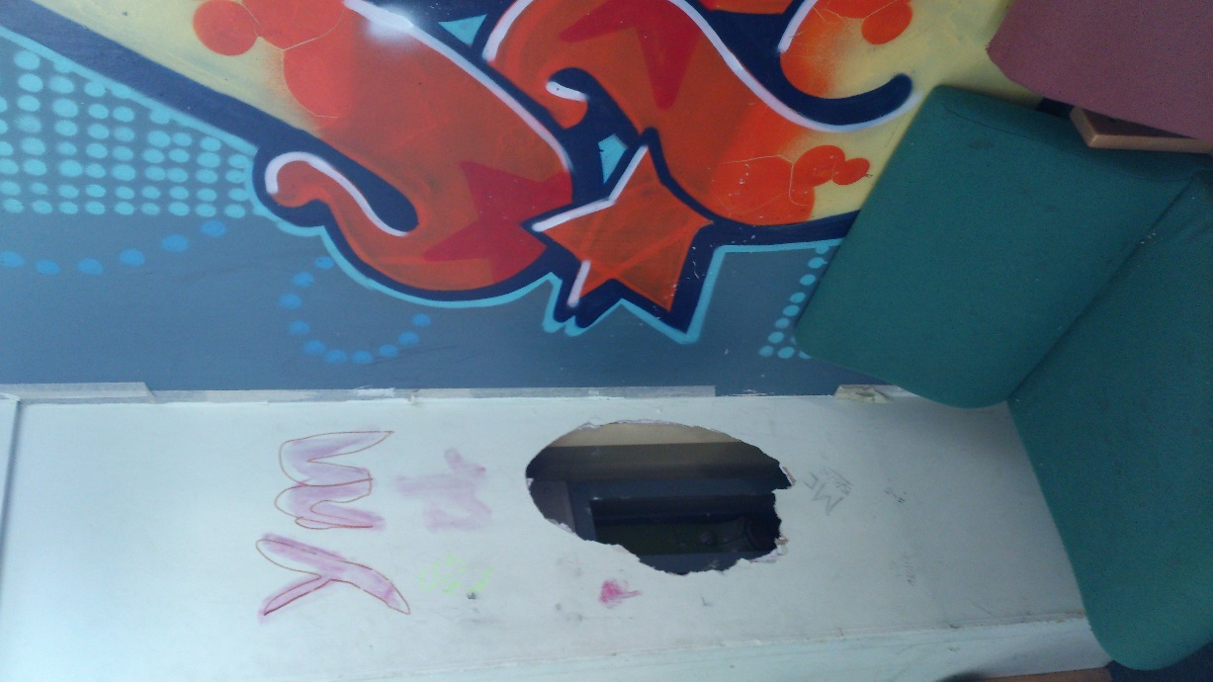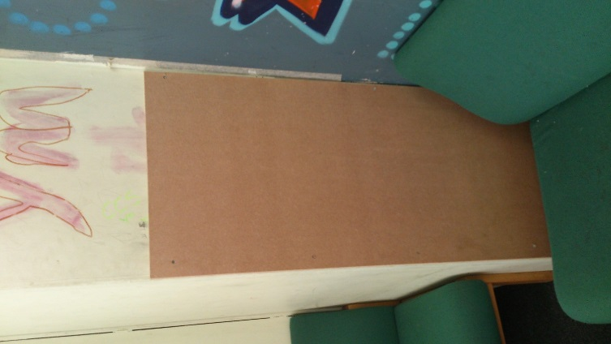

**Thank you Sainsbury’s! From all at FetLor Youth Club**

**And a front door that opens easily again, even in wet weather!**

