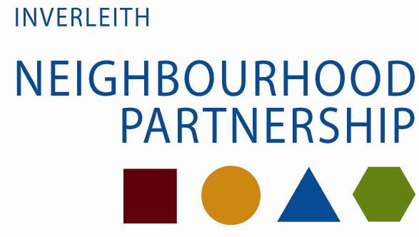

The date of the next meeting of the Inverleith Neighbourhood Partnership is

Wed 6th November 2013,

Blackhall Library, 56 Hillhouse Road, 7.30 – 9.30

All welcome to attend!

 Let’s talk about saving and spending money. Come have your say on the Council’s

draft budget for 2014/15 and beyond!

Plus:

* Local Community Grants
* Roads £50k spend

For papers and agenda, please contact Elaine

on 529 5270, or visit <http://ow.ly/cCO4b>