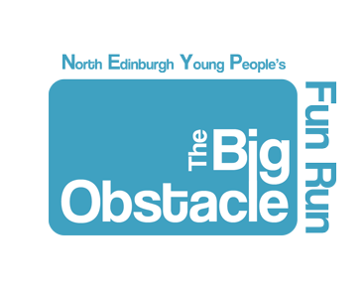
Participant information booklet
Sunday 2nd July 2017
Inverleith Park

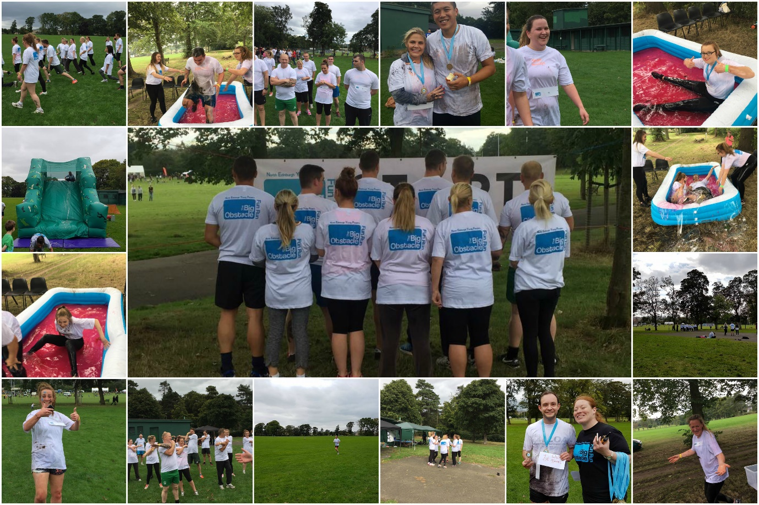

EVENT DAY TIMETABLE
Time
13.20 | Young People’s registration
13.50 | Young people’s warm up
14.00 | Young people’s run begins
14.20 | Adult’s registration
14.50 | Adult’s warm up
15.00 | Adult’s run begins
16.00 | The Big Obstacle Ends

THE COURSE
The Big Obstacle is a 4k course with obstacles throughout. The race will take place at Inverleith Park and there will be 11 obstacles in total.
COURSE SAFETY
The Big Obstacle is a fun event organised by Granton Youth Centre’s youth volunteers, for the benefit of young people and adults. We wish to make the run as safe as possible, so runners, spectators and helpers are asked to:
- Please be considerate to the park and other park users at all times.
- Take care near roads and car parks - some vehicles drive very quickly. Please congregate away from the cars and be careful in particular if you have children. If you’re driving to the event, please drive carefully even if you’re late!
- When running, take care on uneven surfaces - whether on grass or on tarmac. Watch out for cyclists, other runners, pedestrians, children, dogs, wildlife, park animals, vehicles, park maintenance work, falling branches, bollards, posts.
- Remember to join in and do the warm up before the run.
- If you see a runner with a serious problem, please stop to help them out and inform one of the marshals for help as soon as possible.
- If you’re watching, keep clear of runners on the course, and look after any children and dogs you may have with you.

GETTING THERE

bus

Lothian Buses: 8, 19, 21, 23, 24, 27, 29, 37, 38, 42, 47 with a short walk to the location

car
On street parking is available

Please register by the Gazebo which will be beside the Edinburgh Leisure changing rooms at the entrance on Arboretum Place.

ADDITIONAL INFORMATION
All runners must attach their race number, given at the registration desk, to the front of their top with safety pins provided. If you suffer from any medical conditions please write them on the back of your race number. You will also be given a wristband and t-shirt when you register and you must wear this for the duration of the run.

FACILITIES
Public Toilets are available.
Changing rooms will also be available so please bring a change of clothes for after the event, you will be messy, sticky and wet!
No storage facilities are available but changing facilities are. Please do not leave valuables lying around as if there is any loss or damage to property, then liability cannot be accepted by Granton Youth Centre. If possible have a friend spectating and leave possessions with them.

Marshalls positioned along the route are there to assist you, they will be identifiable as they will be wearing black t-shirts with The Big Obstacle logo on them.
EVENT CHECKLIST
Please make sure you bring:
A bottle of water
A hoodie or warm jacket
A change of clothes!!!
We look forward to seeing you on the 2nd July 2017 and hope you are ready for the fun run!

The Big Obstacle is registered under Granton Youth Centre, Scottish Charity No. SC031622. Registered organisation 3-11 West Granton Road, Edinburgh, EH5 1HG. 0131 467 5854
Twitter: @TheBigObstacle
Email: thebigobstacle@grantonyouth.com

