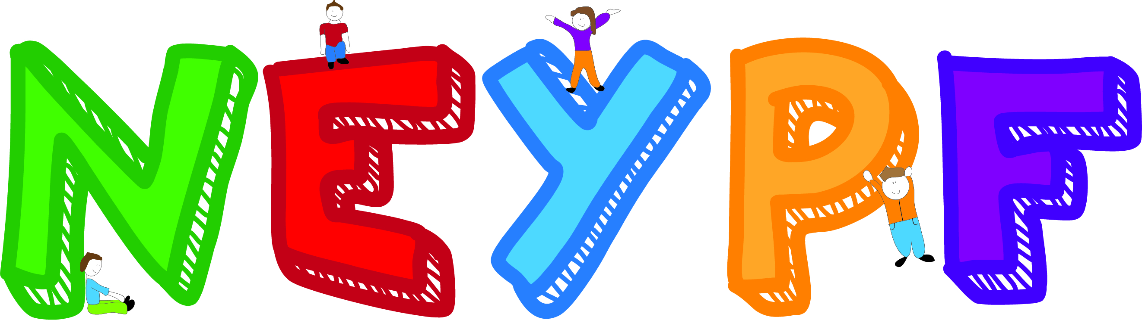
(Organisations)

We are North Edinburgh Young People’s Forum and we represent young people in the Forth/Greater Pilton area. Taking their opinions onboard and acting upon them through our participation in decission making processes. The purpose of this review is to reflect on what we have done and what we can do differently in order to help better improve our service and projects. Through feedback from the community, various agencies/organsations, staff and ourselves we will then compile this informtion and feedback into a report to inform people of the work and impact of the youth forum. As well, as the report becoming a working document for the youth forum to attempt to make the improvements suggested and work around any issues highlighted. We would also like to take this chance to say thank you to everyone who is feed backing to us and helping and supporting us through this review.

- If you could rate us on a scale of 1 – 10 as a group/project but also in relation to the work we do, what would you give us? (please circle)
(1 being the poorest and 10 being the strongest)

1 2 3 4 5 6 7 8 9 10

Why you gave the rating you did:

- Do you feel your organisation/project knows enough about us?
(If no then what can we do to ensure yous do know enough)

- Do we work with your organisation for anything?
(e.g. Partner project or on your steering group, etc)

- If you answered yes to question three, then do you think we have a positive, successful partnership with each other?
(If not what can we do to strengthen it)

- Any Other Comment…

Thank you for taking the time to complete this questionnaire
If you would like a copy of the review report once it is all done then please leave your name and an email address below...

Name:…………………………………………………………………………………..

Email:……………………………………………………………………………………

