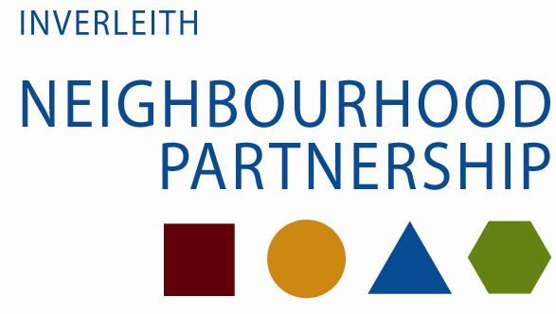
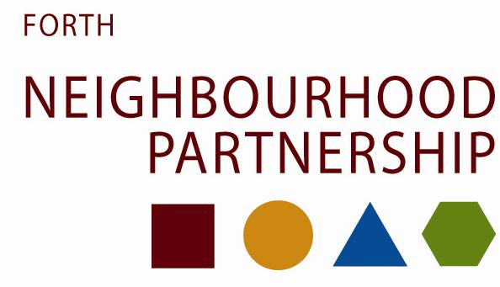

Neighbourhood Partnerships – Making it happen
Following extensive consultation, the Forth and Inverleith Neighbourhood Partnership’s new local community plans for 2014-17 will be launched on 27th October! These will be available online at www.edinburghnp.org.uk/forth or www.edinburghnp.org.uk/inverleith, from your local library or from your North Neighbourhood Office at 8 West Pilton Gardens.
Working with communities and partners, Neighbourhood Partnerships aim to tackle priority issues and make neighbourhoods a better place to live. They bring together the community, Police, Health, Fire, voluntary sector and elected members, and are supported by officers from the Council.
To find out how to get involved in your local Neighbourhood Partnership, visit one of our events, attend a Neighbourhood Partnership meeting or talk to us face to face. Please call 529 5050 or email jim.pattison@edinburgh.gov.uk (Forth NP) or elaine.lennon@edinburgh.gov.uk (Inverleith NP) for more information.
You can also contact us online - tweet us your thoughts @north_team or @Edin_NPs

